**Instructions**

Complete the methods, results and conclusions session of the paper One Should Not Be Flexible - One Should Be Strong: a Study on Work-Family Boundary Strength”. A simplified version of the proposed model must be tested:

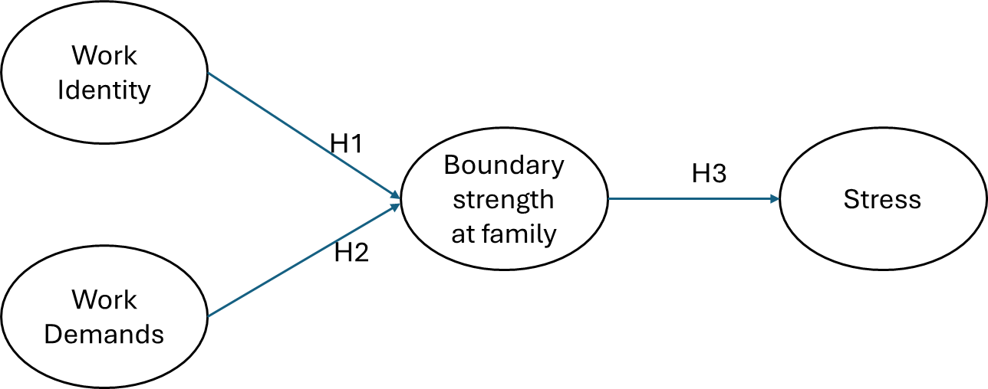

First run a CFA for each “layer” of constructs (Work identity and Work demands together, then Boundary strength at Family and Stress independently).

Comment on any eventual changes made in the measurement models (i.e. exclusion of indicators). It is not allowed to correlate errors under any circumstance!

Run the structural model to test the hypotheses.

Report all relevant indicators and tests.

**SCALES**

**CONSTRUCT: WORK DEMANDS**

**Source:** Boyar, S. L., Carr, J. C., Mosley Jr., D. C., & Carson, C. M. (2007). The Development and Validation of Scores on Perceived Work and Family Demand Scales. *Educational & Psychological Measurement*, 67(1), 100-115.

Dem_Trab1 - I feel like I have a lot of work demand.

Dem_Trab2 - My job requires all of my attention.

Dem_Trab3 - My work requires a lot from me.

Dem_Trab4 - I am given a lot of work to do.

**CONSTRUCT: BOUNDARY STRENGTH AT FAMILY (BSF)**

**Source:** Hecht, T. D., & Allen, N. J. (2009). A longitudinal examination of the work–nonwork boundary strength construct. *Journal of Organizational Behavior*, 30(7), 839-862. Retrieved from EBSCO*host*.

Força_Fam_1_R - I often do work at home. (R)

Força_Fam_2 - I never do work when I am with my family.

Força_Fam_3 - I never take my work out of the ‘‘office.’’

Força_Fam_4_R - I often work ‘‘after hours.’’ (R)

Força_Fam_5_R - I often deal with work-related issues when I am with my family (R)

Força_Fam_6 – I don't use family time for work-related matters.

**CONSTRUCT: WORK IDENTITY**

**Source:** Kanungo, R. N. (1982). Measurement of Job and Work Involvement. *Journal of Applied Psychology*, 67(3), 341-349.

Id_Trab_1 - The most important things that happen to me involve my present job

Id_Trab_2_R - To me, my job is only a small part of who I am

Id_Trab_3 - Most of my interests are centered around my job

Id_Trab_4 - I like to be absorbed in my job most of the time

Id_Trab_5 - Most of my personal life goals are job-oriented

**CONSTRUCT: OCCUPATIONAL STRESS**

**Source**: PASCHOAL, Tatiane; TAMAYO, Álvaro. Validação da escala de estresse no trabalho. Estud. psicol. (Natal),  Natal,  v. 9,  n. 1, abr.  2004

Estresse_1 - Costumo ficar nervoso com a forma como as tarefas são distribuídas no meu setor de trabalho

Estresse_2 - A competição no meu ambiente de trabalho tem me deixado de mau humor

Estresse_3 - Fico irritado com discriminação/favoritismo/politicagem no meu ambiente de trabalho

Estresse_4 - Fico de mau humor por ter que trabalhar durante muitas horas seguidas

Estresse_5 - A falta de compreensão sobre quais são minhas responsabilidades no meu trabalho tem me causado irritação

Estresse_6 - Fico nervoso por ter um tempo insuficiente para realizar meu volume de trabalho